- ZooKeeper is a distributed co-ordination service to manage large set of hosts.
- Co-ordinating and managing a service in a distributed environment is a complicated process. ZooKeeper solves this issue with its simple architecture and API. ZooKeeper allows developers to focus on core application logic without worrying about the distributed nature of the application.
- The ZooKeeper framework was originally built at “Yahoo!” for accessing their applications in an easy and robust manner. Later, Apache ZooKeeper became a standard for organized service used by Hadoop, HBase, and other distributed frameworks. For example, Apache HBase uses ZooKeeper to track the status of distributed data.
- What is distributed application?
  - A distributed application can run on multiple systems in a network at a given time (simultaneously) by coordinating among themselves to complete a particular task in a fast and efficient manner.
  - Normally, complex and time-consuming tasks, which will take hours to complete by a non-distributed application (running in a single system) can be done in minutes by a distributed application by using computing capabilities of all the system involved.
  - A group of systems in which a distributed application is running is called a Cluster and each machine running in a cluster is called a Node.
  - A distributed application has two parts, Server and Client application. Server applications are actually distributed and have a common interface so that clients can connect to any server in the cluster and get the same result. Client applications are the tools to interact with a distributed application.
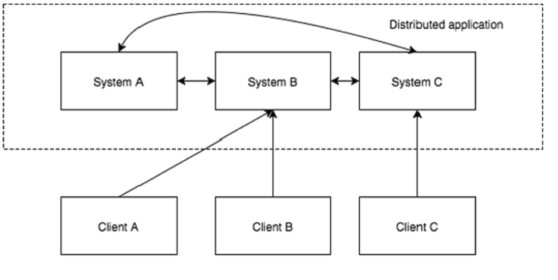
- Benefits of distributed applications
  - Reliability − Failure of a single or a few systems does not make the whole system to fail.
  - Scalability − Performance can be increased as and when needed by adding more machines with minor change in the configuration of the application with no downtime.
  - Transparency − Hides the complexity of the system and shows itself as a single entity / application.
- Challenges of distributed applications
  - Race condition − Two or more machines trying to perform a particular task, which actually needs to be done only by a single machine at any given time. For example, shared resources should only be modified by a single machine at any given time.
  - Deadlock − Two or more operations waiting for each other to complete indefinitely.
  - Inconsistency − Partial failure of data.
- What is Apache Zookeeper meant for?
  - Apache ZooKeeper is a service used by a cluster (group of nodes) to coordinate between themselves and maintain shared data with robust synchronization techniques.
  - ZooKeeper is itself a distributed application providing services for writing a distributed application.
  - ZooKeeper is a distributed coordination service designed for managing and synchronizing configuration information, naming, distributed synchronization, and group services in large-scale distributed systems. It provides a highly available and fault-tolerant way to manage shared resources and metadata across a cluster of machines.
- Zookeeper Architecture:
  - ZooKeeper Ensemble:
    - A ZooKeeper ensemble consists of multiple ZooKeeper servers (usually an odd number like 3, 5, or 7) running on different machines.
    - These servers work collaboratively to provide a reliable service. ZooKeeper relies on a majority vote for decisions and data consistency, so having an odd number of servers helps avoid ties during elections.
  - Znodes:
    - ZooKeeper organizes data into a hierarchical namespace similar to a file system, where each node is called a "znode."
    - Znodes can be of two types: ephemeral and persistent.
    - Ephemeral znodes exist only as long as the session of the client that created them is active.
    - Persistent znodes remain until explicitly deleted.
  - Leader-Follower Model:
    - Within the ensemble, one server is elected as the leader, while the others become followers.
    - The leader is responsible for processing all client requests for updates, such as creating or deleting znodes, and broadcasting these updates to the followers.
    - Followers replicate the state from the leader and can serve read requests from clients.
  - Watches:
    - ZooKeeper allows clients to register watches on znodes. These watches are event notifications that trigger when certain znode changes occur (e.g., data modification, znode creation/deletion).
    - Watches help clients react to changes in the distributed system without continuous polling.
- How ZooKeeper Works:
  - Client Interaction:
    - Clients interact with ZooKeeper servers to read and write data, create znodes, and register watches.
    - The client can connect to any ZooKeeper server in the ensemble, and that server will redirect the client to the current leader.
  - Data and Transaction Log:
    - ZooKeeper stores all data and transaction history in a replicated transaction log.
    - Each server in the ensemble maintains a copy of this log. It allows ZooKeeper to recover data and maintain consistency in case of server failures.
  - Quorum and Consensus:
    - ZooKeeper uses a quorum-based approach to achieve consensus among servers. A majority (quorum) of the servers must agree on an operation before it's considered successful.
    - This ensures that data consistency is maintained even if some servers in the ensemble fail or become unreachable.
- Use Cases:
  - Configuration Management: ZooKeeper is often used to store and manage configuration settings for distributed applications.
  - Distributed Locks: Zookeeper provides primitives for implementing distributed locks, allowing coordination among distributed processes.
  - Leader Election: ZooKeeper can be used to elect a leader among a group of nodes for tasks like load balancing or failover.
  - Service Discovery: ZooKeeper is employed to help applications and services dynamically discover and keep track of the availability and locations of other services within a distributed environment. This is particularly valuable in microservices architectures, cloud computing, and other scenarios where services need to locate and communicate with each other efficiently.
- Abc

